**Digital to Physical**

Zakaria Ahmed

**1.1 Game Premise**

The game is a Dnd rpg campaign in which the world is in an ocean with many islands to explore, the world is set in an assassins creed inspired pirate era where countries conquered islands whilst pirated invade for the treasure upon them. Majority of the game comprises of turn based combat which can be influenced by the items gathered throughout the world that players may use. Furthermore, there is a compelling story to be had that features refences from the assassins creed. 2 to 4 players are recommended for this campaign.

**1.2 Mechanics**

**Attacking** - Inspired by D&D mechanics, players use a 20 sided die to roll to attack and a damage die depending on the weapon they use. Players must meet or beat the enemy’s defence value in the attack die in order to deal damage to them

**Combat** - during combat players and enemies fight in turn based phases, if someone misses their attack then the turn is passed onto the next. Anyone can move, attack or use items in their turn.

In addition, players start and find many weapons that have different attack/damage values. For example, a “sharpened sword” may deal a +1 to damage on top of a 6 sided die.

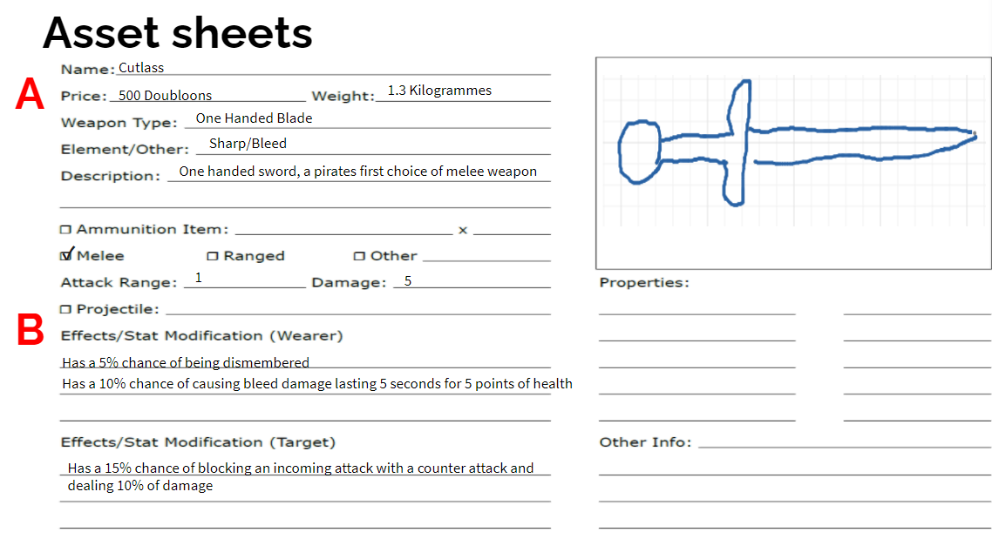

**Figure 1: This shows an example of a weapon in game. “A” price is its in-game value whilst “B” prompts the user on the damage modifier of the weapon**

**1.3 Gameplay**

The game is heavily inspired by Dnd tabletop games so many of the gameplay takes similar approaches. For example, players create their own character using a character sheet, likewise enemies are also created using the sheet and can interact with the players using the mechanics mentioned previously. The players creations can have an impact on the choices they make depending on how the player was created, urging a flexible way of gameplay that is different to other playthroughs.

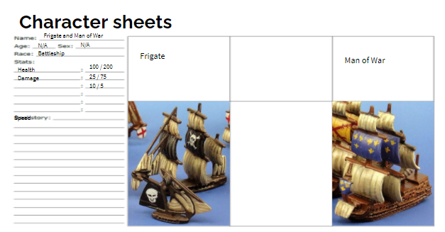

**Figure 2: this shows an example of an enemy character sheet where “Health” and “Damage” will tell us how much health/damage they can do in the campaign**

On the other hand, the board is unchanged and instead provides many islands to travel to, each ranging from difficulty and what they provide 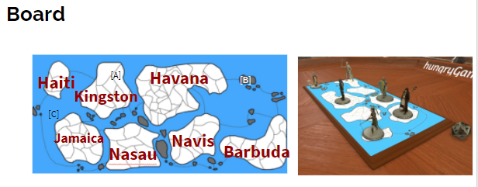

**Figure 3: shows land where you can gain items but has a higher chance of conflict “A”, you can hide behind these rocks to avoid being seen “B” and you traverse water with fewer but tougher enemies “C”.**

**Play testing**

After discussing the game’s development up until this point, one concern that the team shared was that there were no goals within the game. Yes, the creativity of the role playing game meant that the players can play how they wanted, but if the players seemed lost then it discouraged play and this was not intended.  
  
From this we decided to include factions in the game that would introduce a main storyline for all playthroughs. Three factions (Assassins,Spanish and English) in which the players are assassins, tasked with eliminating the other factions. Ultimately they will have to defeat the enemy factions in order to bring peace to the lands.

By having this, all players that played onwards had a main storyline they would follow that ultimatley fixing our problem.

**Working in teams**

Working in teams is highly encouraging as the experience from this is very benefiting. Brainstorming ideas for the game, we would collectivley share our ideas and together developed our game using all of our thoughts.

Unfortunatley, an improvement would be to have physical instances of this board game for better developing as restrictions were in place duing our time that forced all development to be created digitally.

Team - Alex Zarnescu, Steven Smith, Zakaria Ahmed and Sean Colbourne